HOMEWORK

1. Draw the shape corresponding to the Boolean expression

a, (x > 2 and x < 4) or (y < 2) 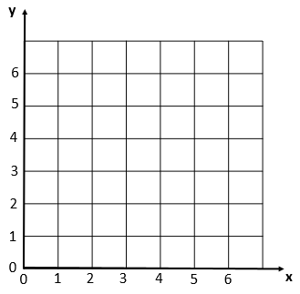

b, (x>2 and x<6) and (y>2 and y<6) and not(x>4)



2, Write the boolean condition for this grid

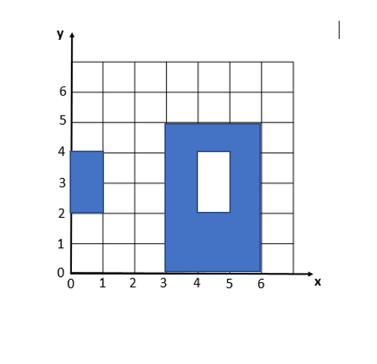



2. Demonstrate these equalities using the 9 simplification rules you have learnt:

* !(C and D) and (!C or D) and (C or !D) = !C

!(C and D) and (!C or D) and (C or !D) = !C or !D and (!C or D) and (C or !D)

= (!C or !D) and (!C or D) and (C or !D)

= !C or (!D and D) and (C or !D)

= !C or False and (C or !D)

= !C or (False and C) or (False and !D)

= !C or False or False

= !C

* ! ( !C and (!B or !C) ) = C

= ![(!C and !B) or (!C and !C)]

= ![( !C and !B) or !C]

= ![!C and (B! Or true)

= !(!C and True )

= !(!C)

= C

* (A and B) or (A and !B) = A

= A and (B or !B)

= A and True

= A

3.. What is the output of flowchart? If x=6 and y = 5 and z = 1 answer: The output flowchart is 7

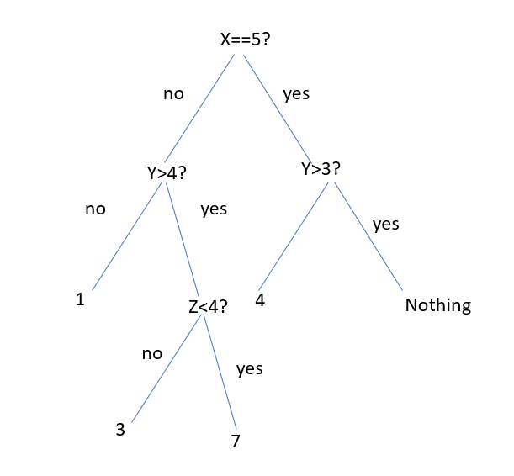

1. Draw the tree of conditions

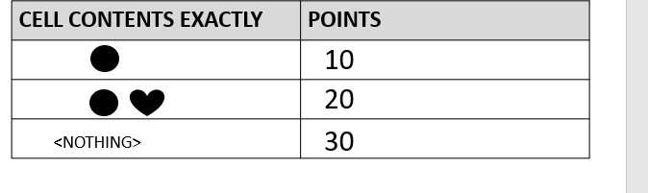





30

0

10

20

1. Draw the tree of conditions

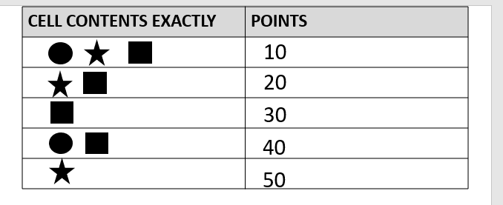



10

40

0

30

0

50

20

1. Draw the tree of conditions

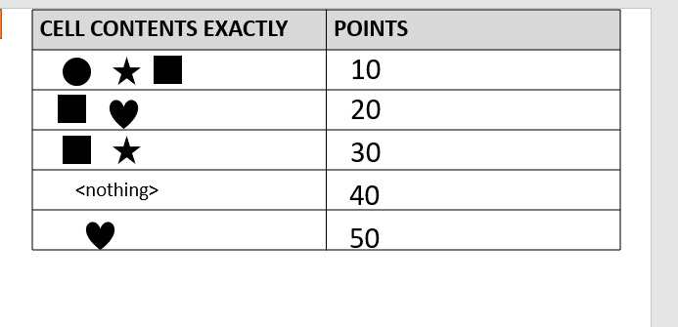





0

0



0

10

40

20



50

0

30

7.

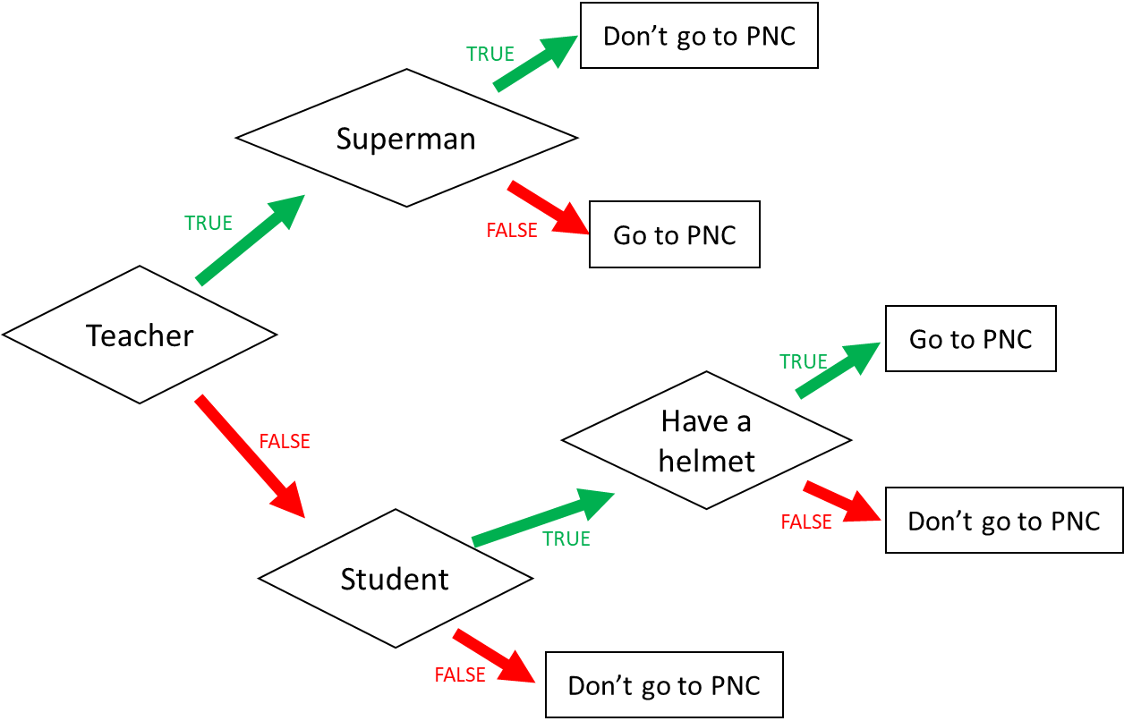

1. I am a teacher and I am superman, can I go to PNC? Don’t go to PNC
2. I am not a teacher and not a student, can I go to PNC? Don’t go to PNC
3. When can I go to PNC? (Express the condition using a Boolean expression)

I go to PNC if: I am a teacher and I am not superman or I am not a teacher and I am student and I have a helmet.

8

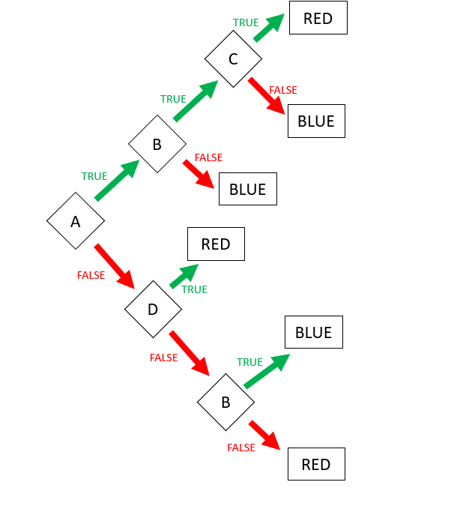

Expression: **RED** = ABC or !AD or !A!D!B

Expression: **BLUE** (FALSE) = A!B or AB!C

9. Encoding

* First 3 characters “MIX”, repeated many times (max repetition is 5)
* Then 1 character “!”, repeated many times (max repetition is 5)
* Then 1 number (0-3)

Examples:

MIXMIXMIX!1

MIX!!!!!3

MIXMIXMIX!!!2

**Q1**. Propose an **encoding** **structure** to encode this image.

|  |  |
| --- | --- |
| Encoding parts | Encoding values (in binary) |
| The repetition of text “MIX”: 1…5 | 001…101 |
| The repetition of character “!”: 1…5 | 001…101 |
| The number of the end: 0..3 | 00…11 |
|  |  |

**Q2**. What is the total **size** of your encoding? Give explanations.

Encoding size:8bits

*Explanation:*

Part1: 101 that mean text of MIX repeated 5 times

Part2: 101 that mean character if ! reqpeated 5 times  
Part3: 11 that mean the number at the end is 3.

We want to encode **a text** following those rules:

* 3 letters: A, B, C
* The letters are always in the alphabetic order
* Letters are repeated from 1 to 10 times
  + Each letter is repeated the same number of times
* The last character must be either: X, Y, or Z

*Examples:*

|  |  |
| --- | --- |
| ABCZ | Good |
| AAAABBBBCCCCX | Good |
| AABBCCY | Good |
| AAABBBCCCX | Good |
| AABBBBCCX | Bad: letter A is repeated 2 times but letter B 3 times |

**Q1**. Propose an **encoding** **structure** to encode this image. (20pts)

|  |  |
| --- | --- |
| Encoding parts | Encoding values (in binary) |
| The repetition of letter A,B,C (1...10) | 0001...1010 |
| The letter at the end x,y,z (0,1,2) | 00,01,10 |

**Q2**. What is the total **size** of your encoding? Give explanations.

Encoding size:(4pts): 6bits

Explanation:(6pts):

Part 1: 1010 The repetition of letter A,B,C (1...10)

Part 2: 10 The letter of the end.